**CORE JAVA GUI(SWING) Based ChatBot**

**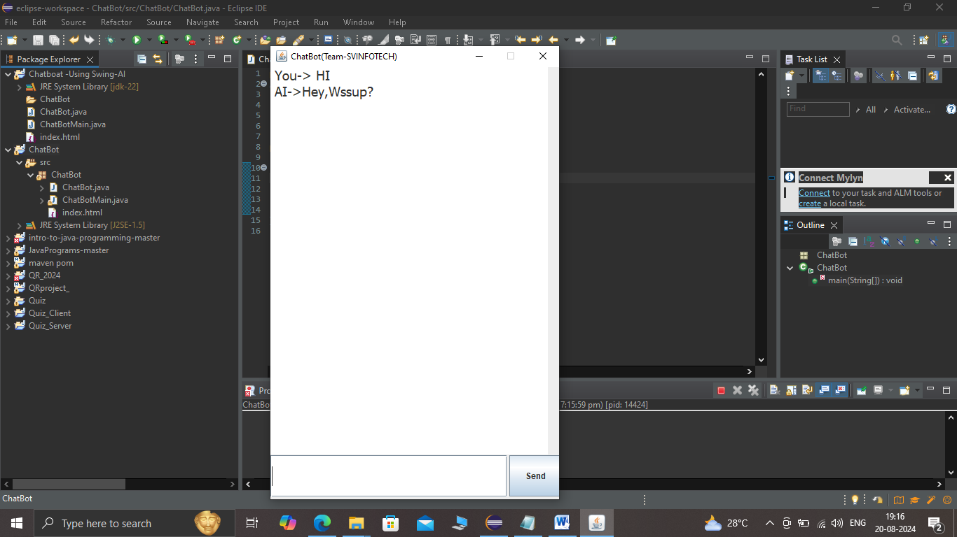**

[**A chatbot is a computer program that simulates human conversation with an end user**](https://www.bing.com/ck/a?!&&p=a0cef8e12a33002cJmltdHM9MTcyNDExMjAwMCZpZ3VpZD0wYTkzYzBlYi03ZDk3LTZkYTUtMjA2OC1kNDI3N2M5MTZjZGUmaW5zaWQ9NTg4Ng&ptn=3&ver=2&hsh=3&fclid=0a93c0eb-7d97-6da5-2068-d4277c916cde&psq=what+is+chat+bot&u=a1aHR0cHM6Ly93d3cuaWJtLmNvbS90b3BpY3MvY2hhdGJvdHM&ntb=1)**(System Generated User).**[**Not all chatbots are equipped with artificial intelligence (AI), but modern chatbots increasingly use conversational AI techniques such as natural language processing (NLP) to understand user questions and automate responses to them**](https://www.bing.com/ck/a?!&&p=9a2770cf8127624bJmltdHM9MTcyNDExMjAwMCZpZ3VpZD0wYTkzYzBlYi03ZDk3LTZkYTUtMjA2OC1kNDI3N2M5MTZjZGUmaW5zaWQ9NTg4OQ&ptn=3&ver=2&hsh=3&fclid=0a93c0eb-7d97-6da5-2068-d4277c916cde&psq=what+is+chat+bot&u=a1aHR0cHM6Ly93d3cuaWJtLmNvbS90b3BpY3MvY2hhdGJvdHM&ntb=1)**. [Chatbots can be written or spoken](https://www.bing.com/ck/a?!&&p=d4ea90de0781daa7JmltdHM9MTcyNDExMjAwMCZpZ3VpZD0wYTkzYzBlYi03ZDk3LTZkYTUtMjA2OC1kNDI3N2M5MTZjZGUmaW5zaWQ9NTg5Mg&ptn=3&ver=2&hsh=3&fclid=0a93c0eb-7d97-6da5-2068-d4277c916cde&psq=what+is+chat+bot&u=a1aHR0cHM6Ly93d3cuY291cnNlcmEub3JnL2FydGljbGVzL3doYXQtaXMtYS1jaGF0Ym90P21zb2NraWQ9MGE5M2MwZWI3ZDk3NmRhNTIwNjhkNDI3N2M5MTZjZGU&ntb=1" \t "_blank)**

**To understand How ChatBots actually works we hereby designed a simple GUI based java program which takes some tokens as strings and based on Predefined learning we have simulated their Answers**

**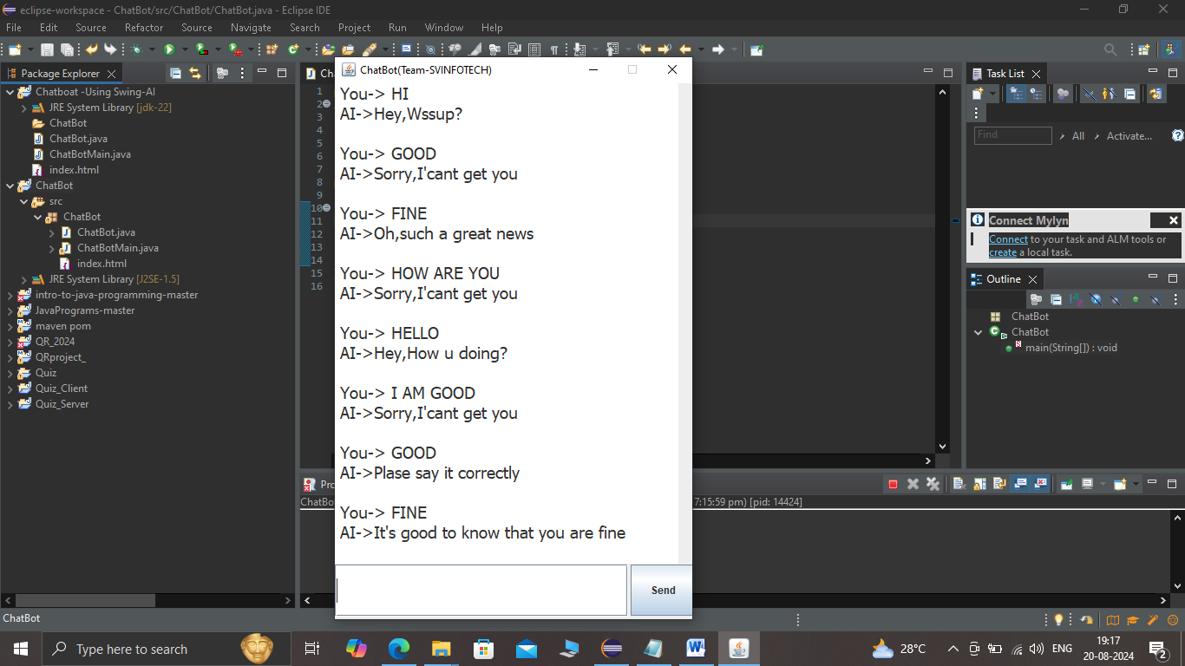**

*Chat based on predefined Tokens*

**Source code of ChatBot.java:**

package ChatBot;

/\*\*

\*

\* **@author** HIMANSHU

\*

\*

\*/

public class ChatBot {

public static void main(String[] args) {

ChatBotMain obj=new ChatBotMain();

obj.setTitle("ChatBot(Team-SVINFOTECH)");

obj.setVisible(true);

}

}

**Source code of ChatBotMain.java:**

package ChatBot;

/\*\*

\*

\* **@author** HIMANSHU

\*

\*

\*/

import java.awt.Adjustable;

import java.awt.BorderLayout;

import java.awt.EventQueue;

import javax.swing.JFrame;

import javax.swing.JPanel;

import javax.swing.border.EmptyBorder;

import javax.swing.JTextField;

import javax.swing.JButton;

import java.awt.Font;

import javax.swing.JEditorPane;

import java.awt.event.ActionListener;

import java.awt.event.ActionEvent;

import java.awt.event.KeyAdapter;

import java.awt.event.KeyEvent;

import java.util.Random;

import javax.swing.JTextArea;

import javax.swing.JScrollBar;

import java.awt.event.AdjustmentListener;

import java.awt.event.AdjustmentEvent;

public class ChatBotMain extends JFrame {

private JPanel contentPane;

private JTextField textField\_1;

private JButton btnSend;

private String main="";

JTextArea textArea;

private JScrollBar scrollBar;

/\*\*

\* Launch the application.

\*/

public static void main(String[] args) {

EventQueue.*invokeLater*(new Runnable() {

public void run() {

try {

ChatBotMain frame = new ChatBotMain();

frame.setVisible(true);

} catch (Exception e) {

e.printStackTrace();

}

}

});

}

/\*\*

\* Create the frame.

\*/

public ChatBotMain() {

setDefaultCloseOperation(JFrame.***EXIT\_ON\_CLOSE***);

setResizable(false);

setBounds(100, 100, 428, 657);

contentPane = new JPanel();

contentPane.setBorder(new EmptyBorder(5, 5, 5, 5));

setContentPane(contentPane);

contentPane.setLayout(null);

textField\_1 = new JTextField();

textField\_1.addKeyListener(new KeyAdapter() {

*@Override*

public void keyPressed(KeyEvent e) {

if(e.getKeyCode()==KeyEvent.***VK\_ENTER***)

{

action();

}

}

});

textField\_1.setFont(new Font("Tahoma", Font.***PLAIN***, 23));

textField\_1.setBounds(0, 555, 338, 60);

contentPane.add(textField\_1);

textField\_1.setColumns(10);

btnSend = new JButton("Send");

btnSend.addActionListener(new ActionListener() {

public void actionPerformed(ActionEvent e) {

action();

}

});

btnSend.setBounds(341, 555, 75, 59);

contentPane.add(btnSend);

textArea = new JTextArea();

textArea.setFont(new Font("Tahoma", Font.***PLAIN***, 19));

textArea.setEditable(false);

textArea.setBounds(0, 0, 396, 554);

contentPane.add(textArea);

/\* scrollBar = new JScrollBar();

// scrollBar.setvie

scrollBar.addAdjustmentListener(new AdjustmentListener() {

public void adjustmentValueChanged(AdjustmentEvent e) {

}

});

scrollBar.setBounds(395, 0, 27, 554);

contentPane.add(scrollBar,BorderLayout.EAST);

JScrollBar scrollBar = new JScrollBar();

scrollBar.addAdjustmentListener(new AdjustmentListener() {

public void adjustmentValueChanged(AdjustmentEvent e) {

}

});

scrollBar.setBounds(395, 0, 21, 554);

contentPane.add(scrollBar);\*/

}

void action()

{

String query=textField\_1.getText();

textArea.append(" You-> "+query+"\n");

//query.trim();

query=query.toLowerCase();

if(query.contains("clear screen")||query.contains("clr")||query.contains("cls"))

{

textArea.setText("");

textField\_1.setText("");

}

else if(query.contains("hi")||query.contains("hey")||query.contains("hola")||query.contains("hello"))

{

Random rand=new Random();

int a=rand.nextInt(4);

if(a==0)

{

ai("Hey,I'm Here");

}

else if(a==1)

{

ai("Hey,Wssup?");

}

else if(a==2)

{

ai("Hey,How u doing?");

}

else if(a==3)

{

ai("Hello,u there?");

}

else if(a==4)

{

ai("Hello,How u doing?");

}

}

else if(query.contains("fine")||query.contains("I'm fine")||query.contains("am okay"))

{

Random rand=new Random();

int a=rand.nextInt(4);

if(a==0)

{

ai("It's good to know that you are fine");

}

else if(a==1)

{

ai("It's pleasure to know that you are fine");

}

else if(a==2)

{

ai("Oh,great");

}

else if(a==3)

{

ai("Oh,such a great news");

}

else if(a==4)

{

ai("Wish,you always remain fine");

}

}

else if(query.contains("wssup")||query.contains("whats up")||query.contains("whatsup")||query.contains("wtsup")

||query.contains("you doing")||query.contains("u doing"))

{

ai("I'm fine and what about you");

}

else if(query.contains("yes")||query.contains("yeah")||query.contains("ya"))

{

Random rand=new Random();

int a=rand.nextInt(2);

if(a==0)

{

ai("Oh, Great");

}

else if(a==1)

{

ai("Ohh,Great news");

}

else if(a==2)

{

ai("Nice");

}

}

else if(query.contains("ntnhng")||query.contains("nothing"))

{

Random rand=new Random();

int a=rand.nextInt(2);

if(a==0)

{

ai("Why?");

}

else if(a==1)

{

ai("Why? as per I know you are a very charming person");

}

else if(a==2)

{

ai("Why? Don't waste your time this way");

}

}

else{

Random rand=new Random();

int a=rand.nextInt(4);

if(a==0)

{

ai("Sorry,I'cant get you");

}

else if(a==1)

{

ai("Plase say it correctly");

}

else if(a==2)

{

ai("Please rephrase that");

}

else if(a==3)

{

ai("???");

}

}

}

void ai(String s)

{

textArea.append(" AI->"+s+"\n\n");

textField\_1.setText("");

}

}

**How to RUN this project on Eclipse:**

**1. Define project structure**

**2. Define Two User Defined classes**

**ChatBot.java (main class file)**

**ChatBotMain.java (code definition file)**

**3. press ALT+SHIFT+X for the main class file.**

**GUI will be executed.**

**4. How to make Jar File**

**Right click on project under project structure >>Export>> Runnable Jar file.**

**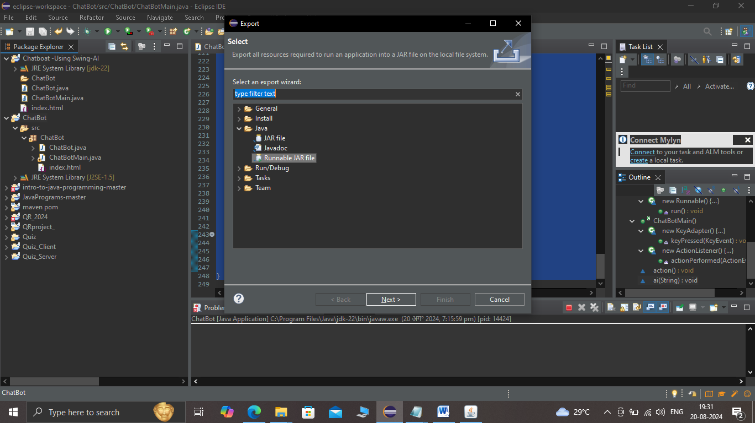**

**TOKENS are defined in action class:**

void action()

{

String query=textField\_1.getText();

textArea.append(" You-> "+query+"\n");

**TOKENS in the form of hi hello hola Namaste.**

//query.trim();

query=query.toLowerCase();

if(query.contains("clear screen")||query.contains("clr")||query.contains("cls"))

{

textArea.setText("");

textField\_1.setText("");

}

else if(query.contains("hi")||query.contains("hey")||query.contains("hola")||query.contains("hello"))

{

Random rand=new Random();

int a=rand.nextInt(4);

if(a==0)

{

ai("Hey,I'm Here");

}

else if(a==1)

{

ai("Hey,Wssup?");

}

else if(a==2)

{

ai("Hey,How u doing?");

}

else if(a==3)

{

ai("Hello,u there?");

}

else if(a==4)

{

ai("Hello,How u doing?");

}

}

else if(query.contains("fine")||query.contains("I'm fine")||query.contains(" I am okay"))

{

Random rand=new Random();

int a=rand.nextInt(4);

if(a==0)

{

ai("It's good to know that you are fine");

}

else if(a==1)

{

ai("It's pleasure to know that you are fine");

}

else if(a==2)

{

ai("Oh,great");

}

else if(a==3)

{

ai("Oh,such a great news");

}

else if(a==4)

{

ai("Wish,you always remain fine");

}

}

else if(query.contains("wssup")||query.contains("whats up")||query.contains("whatsup")||query.contains("wtsup")

||query.contains("you doing")||query.contains("u doing"))

{

ai("I'm fine and what about you");

}

else if(query.contains("yes")||query.contains("yeah")||query.contains("ya"))

{

Random rand=new Random();

int a=rand.nextInt(2);

if(a==0)

{

ai("Oh, Great");

}

else if(a==1)

{

ai("Ohh,Great news");

}

else if(a==2)

{

ai("Nice");

}

}

else if(query.contains("ntnhng")||query.contains("nothing"))

{

Random rand=new Random();

int a=rand.nextInt(2);

if(a==0)

{

ai("Why?");

}

else if(a==1)

{

ai("Why? as per I know you are a very charming person");

}

else if(a==2)

{

ai("Why? Don't waste your time this way");

}

}

else{

Random rand=new Random();

int a=rand.nextInt(4);

if(a==0)

{

ai("Sorry,I'cant get you");

}

else if(a==1)

{

ai("Plase say it correctly");

}

else if(a==2)

{

ai("Please rephrase that");

}

else if(a==3)

{

ai("???");

}

}

}

void ai(String s)

{

textArea.append(" AI->"+s+"\n\n");

textField\_1.setText("");

}

}